Field Log User Guide
Contents
Field Log User Guide 1
Settings 2
File Paths 2
Data Columns 3
Button Configuration 4
Event Codes 5
Monitored Folders 6
SQLite Log 7
Programmed Events 8
Timezone 8
Automatic Sync 9
Main Gui 10
Adding a tab 10
Add new Custom button 10
Configuration buttons 11
Tips 12

The new Onlinelog program was created using Python, which is a change from the old online log that ran on VBA. The program's basic look is similar to the old FLA tool but aims for improved usability and stability. While there may still be some bugs, it has been used on VIRE with few issues. This guide provides a background on how to set up and use the log, along with helpful tips and tricks
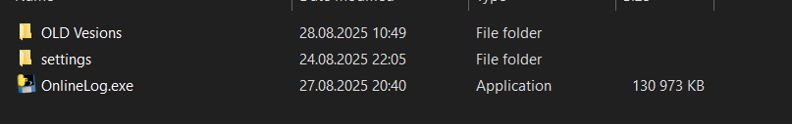
Before using the program, you may need to allow it through your firewall. This was necessary on VIRE, after which it opened without any problems.

The program should be launched from the same location as the settings folder, as this is where it retrieves user settings and button configurations. When the program launches, a separate command (cmd) window also opens. This window is useful for debugging as it displays any code errors. If you press a button and an error occurs, the traceback will appear in this window. This window also shows other information when a button is pressed, which helps you see what the program is doing. You can help correct bugs by logging these errors and passing them on.

Settings
When you open the program, the settings window appears immediately. Here, you must define navigation and folder locations. If you haven't used the program before, it will give you an error stating that no settings file was found and will revert to default settings.

File Paths
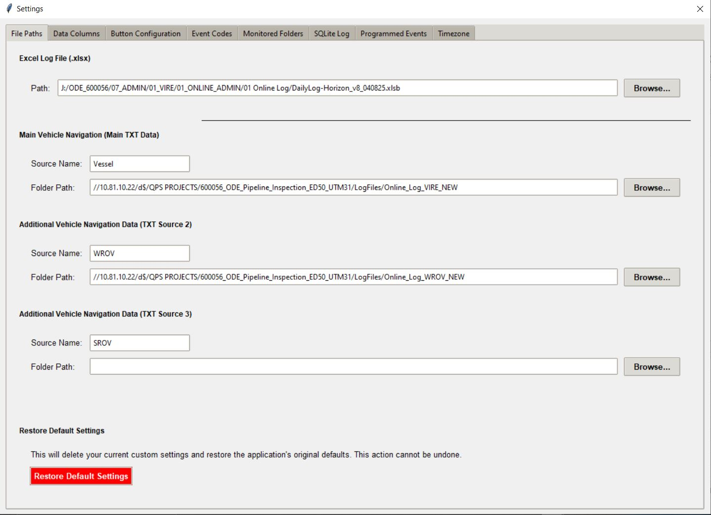
Path is where you select the excel workbook you will be working from
Main Vehicle navigation – This will normally be your vessel navigation CSV text file – you can change the name from vessel if you choose to use a different vehicle as the main system
Additional vehicle – This will be any additional vehicles you may need to add – add the moment we just limit it to 3 vehicles – not sure you need more than this. All the navigation text files should be the same format (Date, Time, KP, Line Name, Vehicle Lat, Vehicle Long, Vehicle Easting, Vehicle Northing) – this is the default that is accepted but you can add more fields which will be covered in the Data Columns section.
Restore Default - There is a restore default settings button which will take you back to the default – default settings will be supplied with the log within the settings folder.

Data Columns
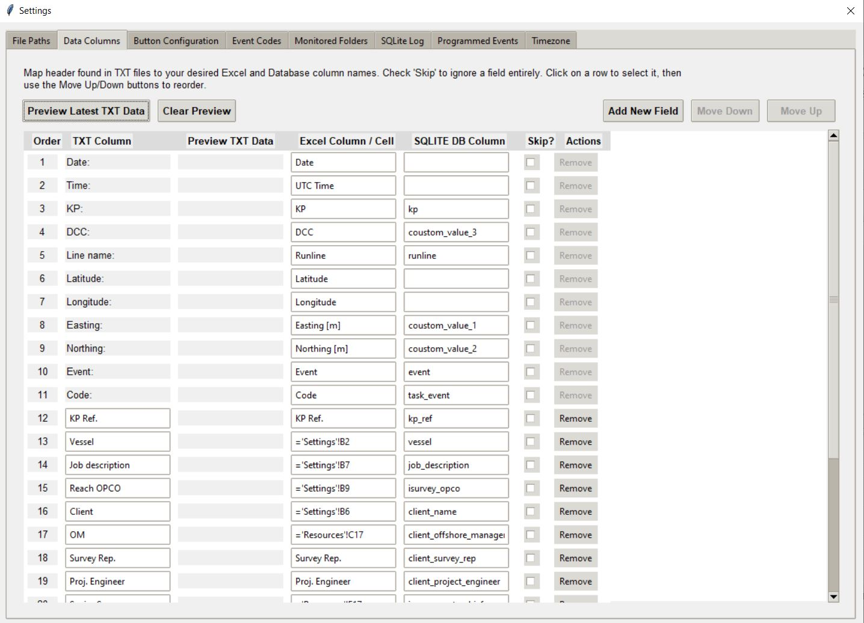
Data columns is where you define the order that your selected text files are being received. The first 10 fields are the default fields which you cannot remove. If you need more fields which are in the in the nav file, then you can add a new field and move it to the next row after these defaults. Likewise, you can reorder the text file. If you want to check its decoding correctly then you can press the preview lates txt data button and it will populate the column Preview TXT Data.
The Excel Column/Cell corresponds to the header of the column you want the field to populate.
The current version is a bit confusing after the navigation file on this page. Columns of static text for the SQlite DB are also defined here from the resources and settings tab in the online log. For example OM is taken from the Resources Tab in excel, and Cell C17, it’s a bit more user involved to define these fields but hopefully we will find a better way to do this in the future. We have set up the defaults to work with the normal SQliteDB table as the office would like the db table to remain the same, however we have added some fields like ‘Original excel row’ which is the primary identifier in the Sqlite. The default table to work with the log will be supplied with the log as well.
If there is a field that you are currently not using but may use again and don’t want to delete it then you can tick the Skip box which will ignore that field and not fill it into the log.

Button Configuration
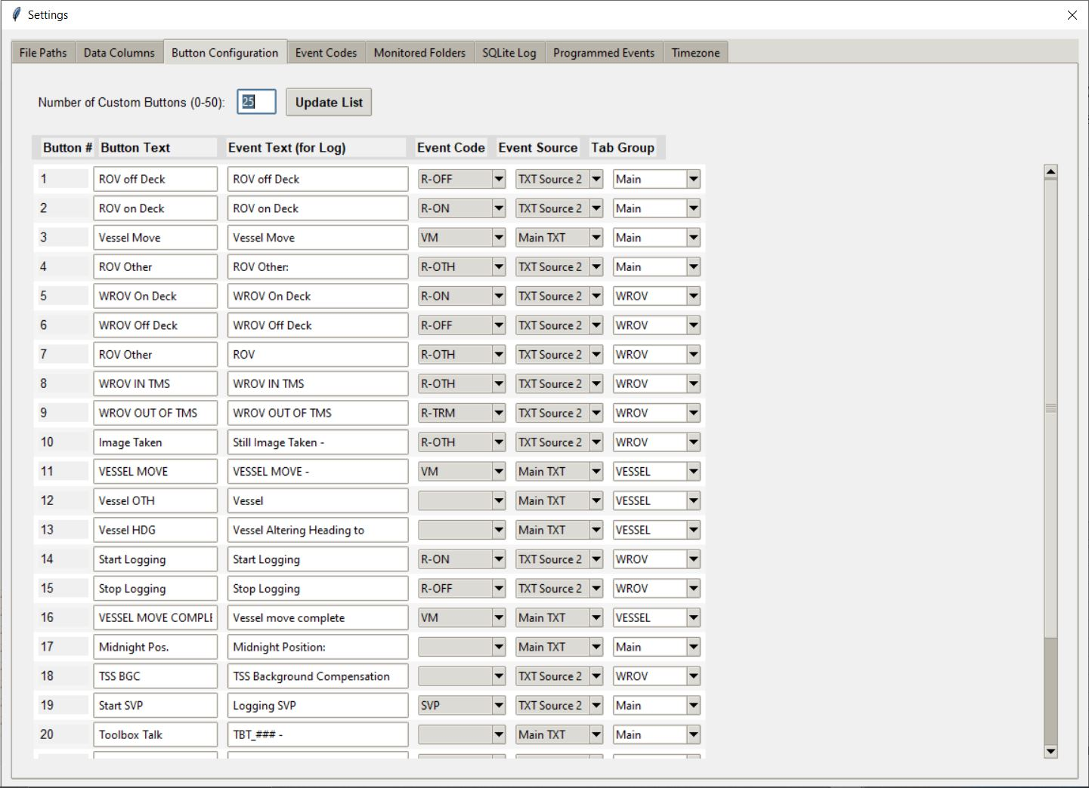
The button configuration tab is an overview of the buttons that are added to the software, you can edit them here but it is also possible to change the options of each button by right clicking it in the GUI. This tab however is good if you want to edit a few buttons quickly.
Button text – the text that appears on the button
Event text – text that is written to the excel workbook
Event code – User defined in the Event codes tab – used for categorizing events in the log – supposed to be used later for the DPR integration for example.
Event source – Which text file the data is taken from for navigation etc
Tab group – which tab in the main GUI the button is placed.

Event Codes
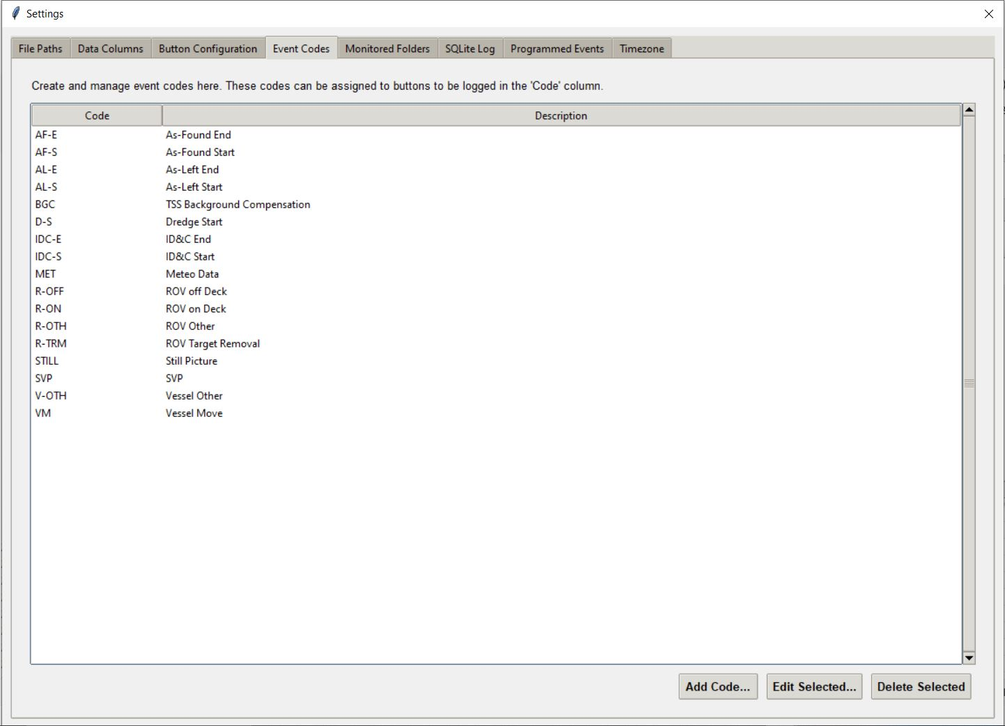
The event codes tab is where the user can add new event codes for assigning to buttons – you add a short code and a description of that code. By using this you reduce error of the user typing a manual code incorrectly.

Monitored Folders
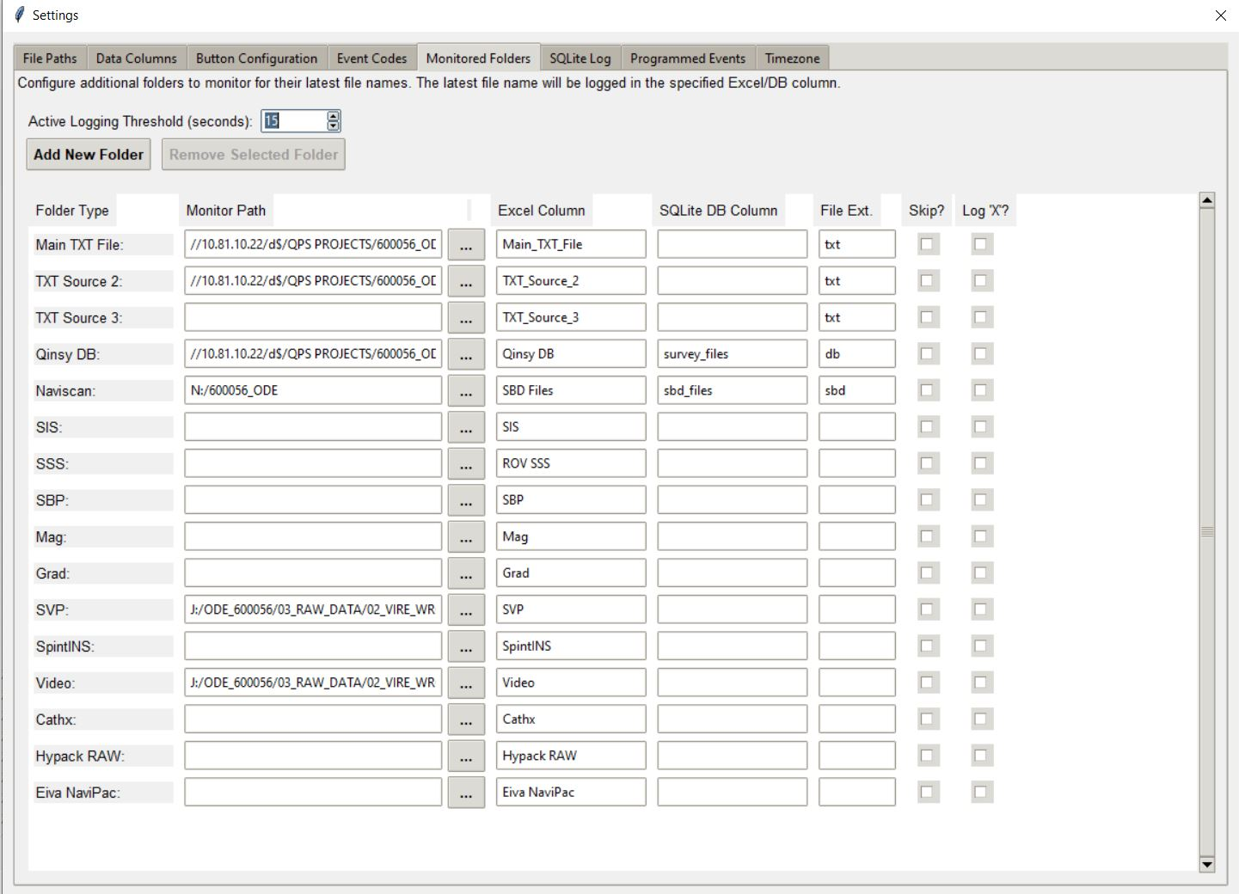
Monitored folders is the folders that are used to take the latest files from for insertion in the online log when the user logs on or logs off.
Monitor path is the path of the folder that the file is located, the program monitors the folder and holds the latest few files in a cache for calling back -this speeds up the log process because it doesn’t have to search the whole folder for the latest file. It also searches subfolders in that folder, so for example naviscan .sbd files which are in julian day folders- the user just selects the main directory and it will look into the subfolders to get the latest file.
Excel Column is the column in excel you want that file name to be placed into, type the header rows text into this
File Ext. is used to only take files with the wanted file extension. If you are logging .sbd but for some reason the latest file is a .txt. The .txt will be ignored.
Again you can skip any that you no longer need
Log X is used for those who wish to only place and X in the column rather than the full file name – The SQL still takes the full file name for the field log viewer.
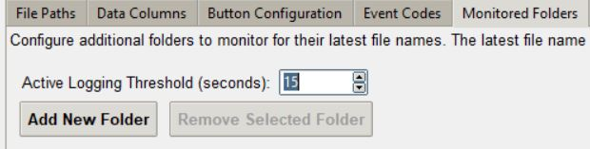
Active Logging: A file is only considered "active" if it was modified within this number of seconds. If the latest file is older than this threshold, the cell in the log will be left blank.

SQLite Log
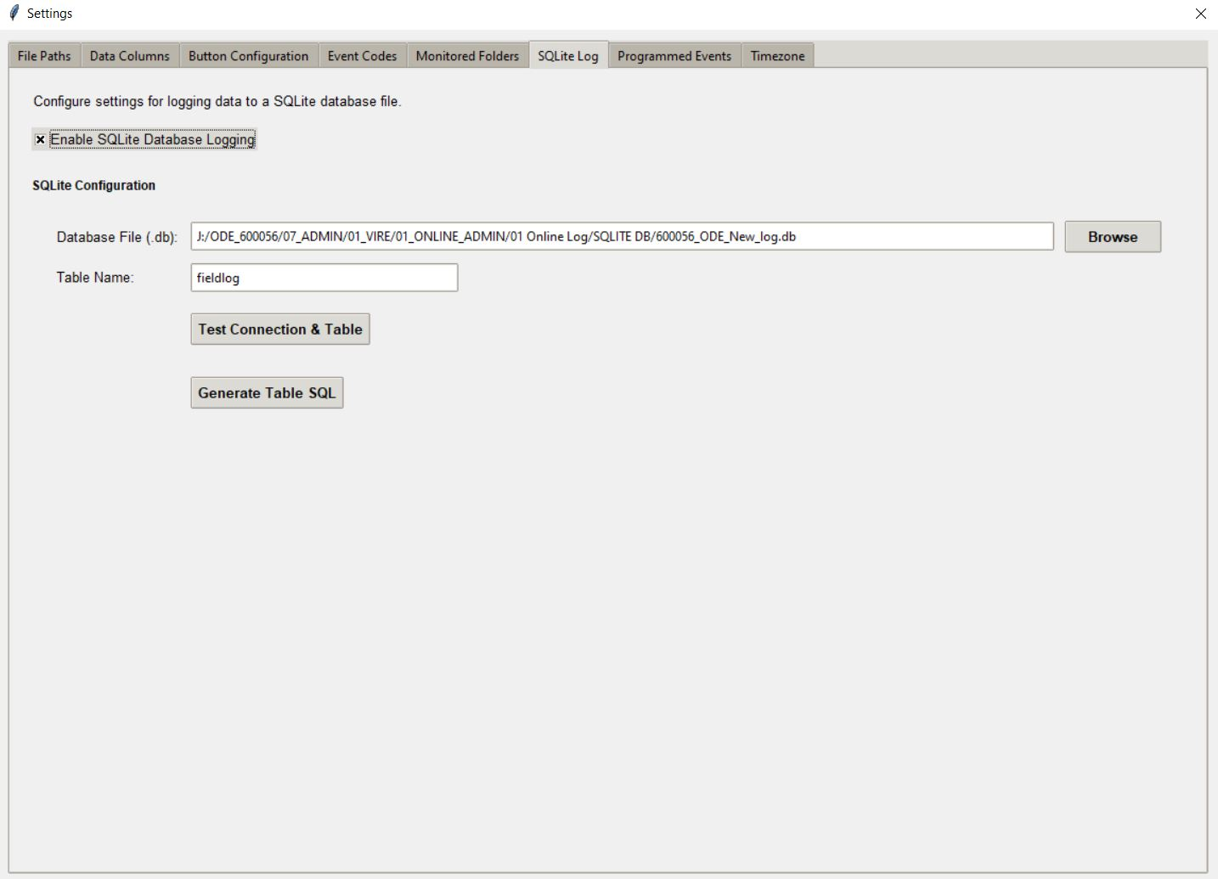
In here the user can activate the SQLite Db logging function. You should select the Db and the table name you want to log to. To check its working you can press the test connection button and it will say if there is an issue.
The generate Table SQL isn’t currently being used, but it does work. It creates the SQL table based on what you have defined in the log for columns. The office wants to keep the current SQL table format as it’s used by other boats.

Programmed Events
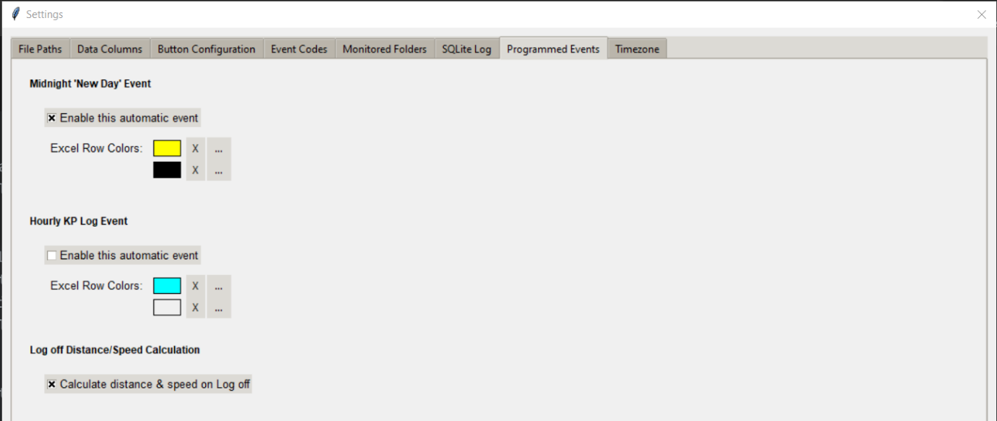
The programmed events auatomatically fills in the excel workbook with a new day if active, and also calculates the last hours distance travelled – The hourly KP is pretty un-tested how well it will work with line changes etc as the kp will not be always increasing for example. This likely wont be very useful in its current function.
The log off distance should be handy, it takes the KP from the last Log on event, and then works out the distance and speed between the log off event. When this is active, the user will press log off and the Event cell will be populated with “Log Off – Distance travelled: XX - Speed XX. If there is no log on event and the user makes a mistake and has two log offs, then it will just read log off, rather than look back for th enext ‘Log on’

Timezone
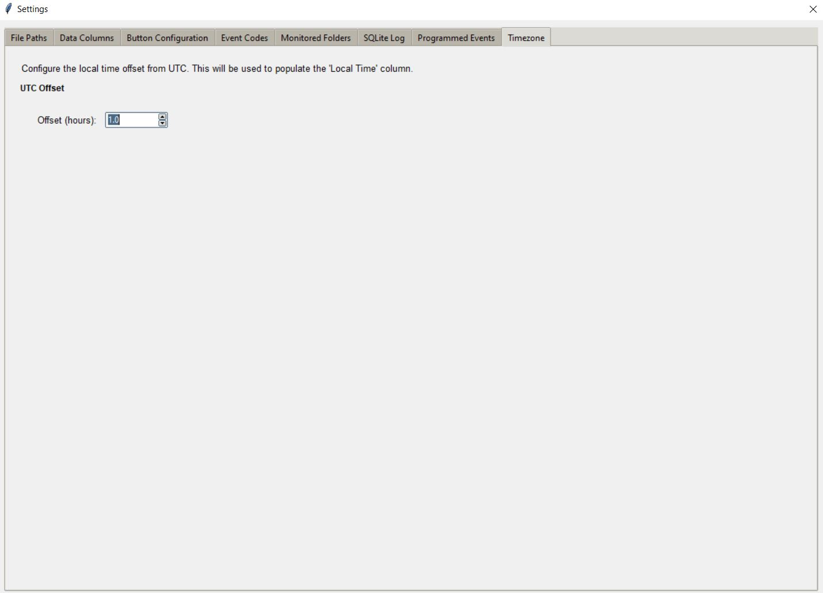
Time zone is used for the offset from UTC Time to local time. The time that is input into the log is taken from PC time which is normally always UTC time on Reach boats. For DPR reporting for example the local time is sometimes also needed.

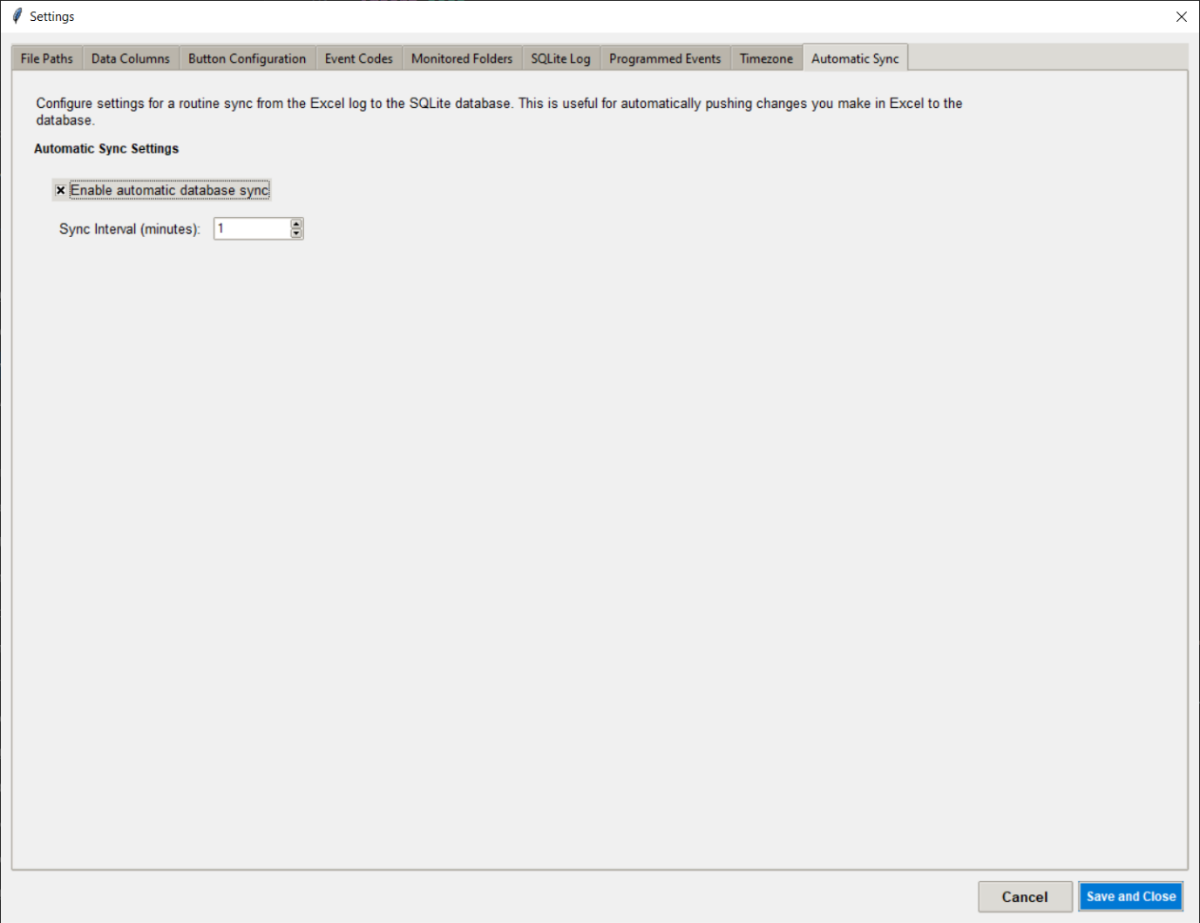
Automatic Sync

When an event is entered into the log its normal that the user will want to edit the text, this edit is not synced to the SQL immediately once made, instead the SQL is updated either by the user pressing the Sync DB button, or more simply by a timed update – in this settings tab you can define how often the sync occurs automatically. Using this function ensures that the field log viewer is kept up to date

Main Gui
The main gui is designed to be similar to the old FLA tool, so it should be fairly familiar to the the user. Many of the functions for adding, editing, removing buttons is done by right clicking in the main gui without having to go into the settings window. The General events are fixed but you can change the colours used by right clicking on the button to bring up the settings. The text file for these is fixed to the main navigation file. The SVP button is handy as it only takes the SVP file name rather than all the other folder when youy use it. The text file data is still used as normal.
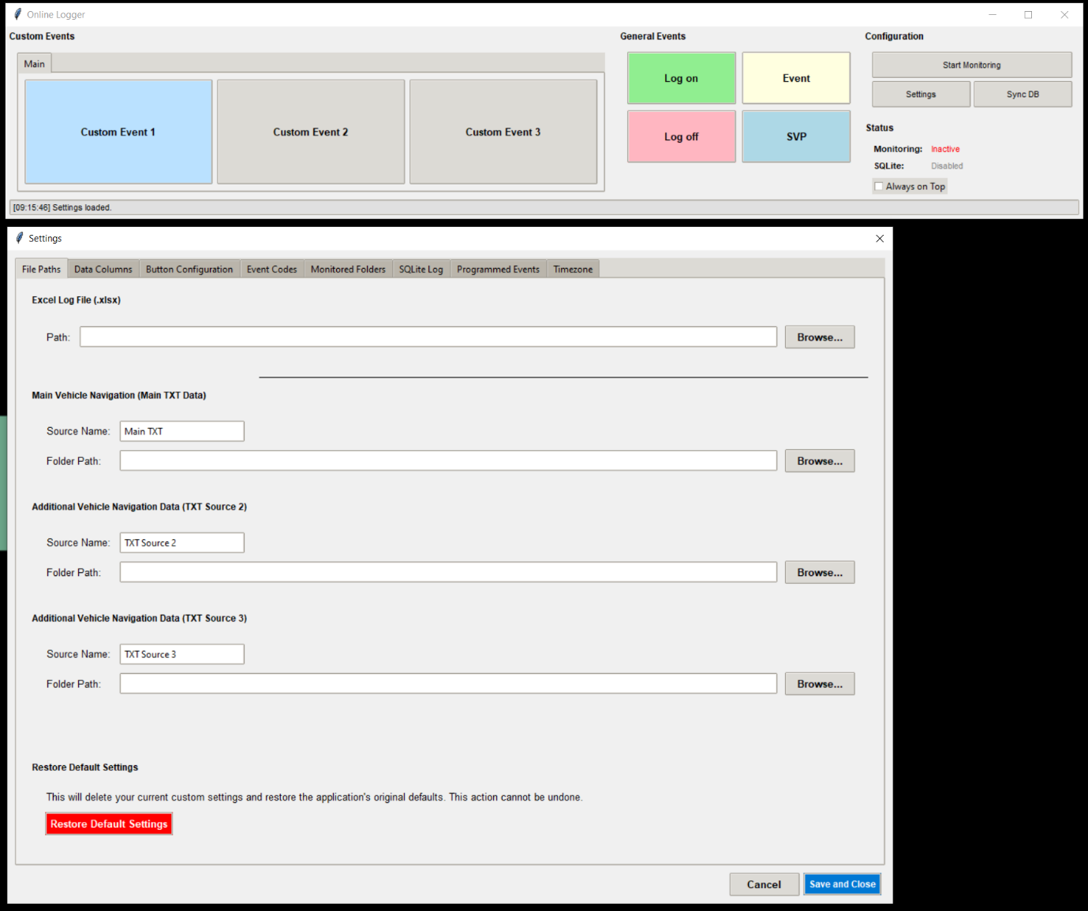

Adding a tab
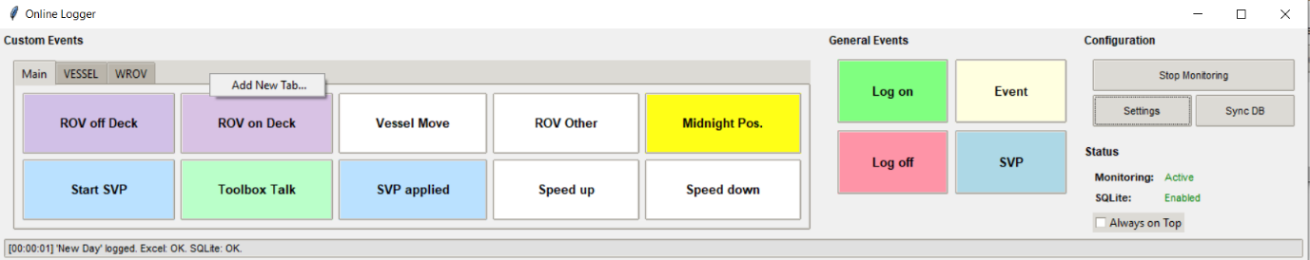
To add a new tab of buttons the user can right click in the tab bar and then select add new tab, this will launch a new window where you can name it what you want, and a new tab will be created with no buttons currently configured.

Add new Custom button
To add a new custom button then you right click on a grey are in the button section and select ‘add new custom button’
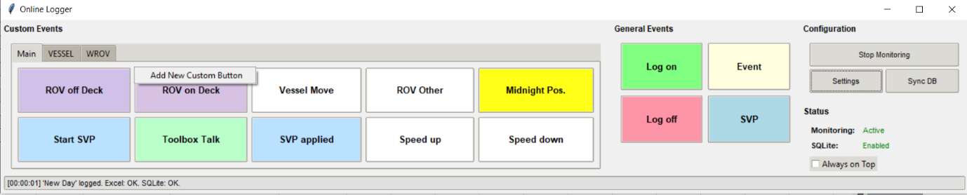
This will launch a new window where you define the button properties
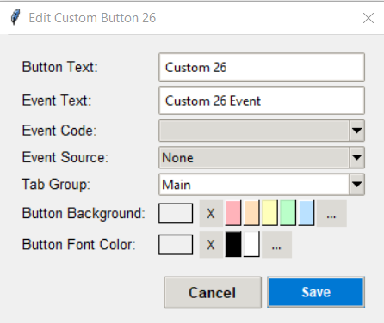
This has the same settings you can change in the custom button tab in the settings window, with the addition of changing the button colour and text colour. Whatever colour you change the button background and text colour to will reflect the same colour of the row and text in excel.
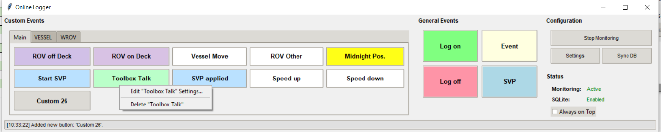
If you right click on a custom button you can edit, which will launch the settings for the button, or delete, which will delete the button.

Configuration buttons
On the right hand side you will see the configuration buttons. By default on startup the folder monitoring is not active. This speeds up the startup of the program because it doesn’t need to search through the folders to start the monitoring. When you are ready to start folder monitoring you press the button and the program will hand up for a but, then a progress bar will appear to show its working before saying folder monitoring started. You do have to be a bit patient at the point but once you get past this it runs very quickly.
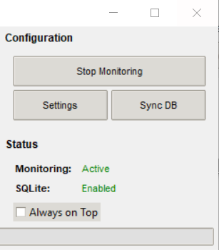
Settings will launch the settings page
Sync Db is used when you make manual changes to the excel workbook, such as delete rows, manually add rows, alter text etc. When you perform a manual change, you need to manually save the workbook, then you can press the “Sync Db” button. This will compare the workbook to the SQLite DB and update it to reflect the excel workbook.
Underneath shows the status of monitoring (folder monitoring) and SQlite db link
When the user uses the manual sync it also creates a back up of the SQL before the sync takes place. This is for redundancy to ensure nothing is lost forever since the sync function also deletes rows that you’ve deleted from the excel workbook.
The always on top can be selected so that the online log gui is always on-top of other windows.

Tips
Button stuck on “working” - If you edit a cell in excel and still have the cell in the edit state, so don’t click out of it after you’ve finished your edit, then when you press a button it will display the text “working” and appear to freeze. This is because you have the edit control still and need to click out the cell you are editing before the program can write to the workbook.
Creating buttons – It doesn’t matter which tab you create a custom button in, it will always default to the main button page – you can select in the settings window which one you want it to be placed into.

